MONGO DB ASSIGNMENT

6. View list of available databases

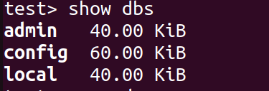

7. Create a new database named CDAC and connect to it
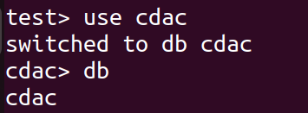

8. View list of available collections in CDAC database

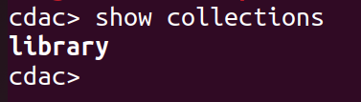

9. Create a new collection by the name of LIBRARY

10. Insert the following document in the LIBRARY collection:-
title:'MongoDB programming', author:'Sameer', likes:100
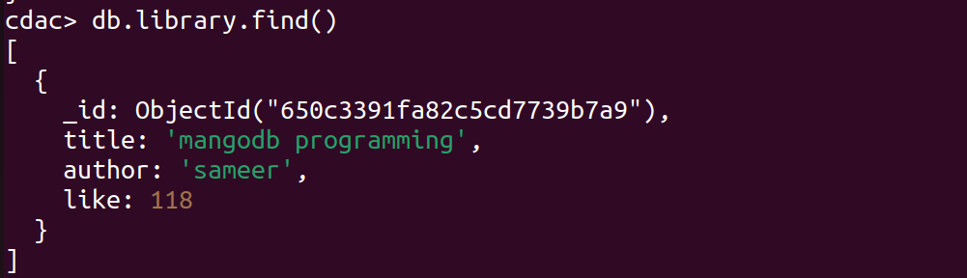
11. View the recently inserted document and note the _id field

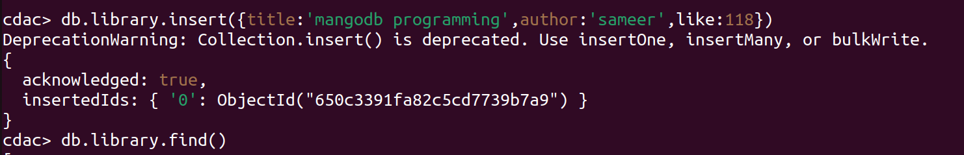

12. Insert another document in the LIBRARY collection as follows:-
title:'MySQL programming', authors:['Jack','Jill'], likes:200
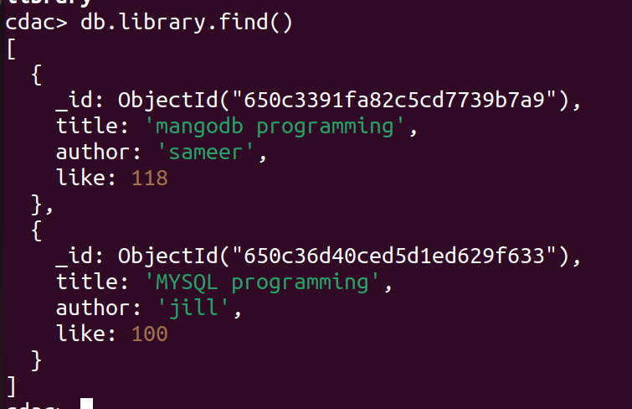

13. View the inserted documents

14. View only the first inserted document

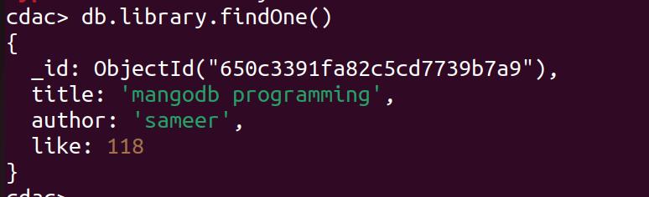
15. View the documents using the pretty() method

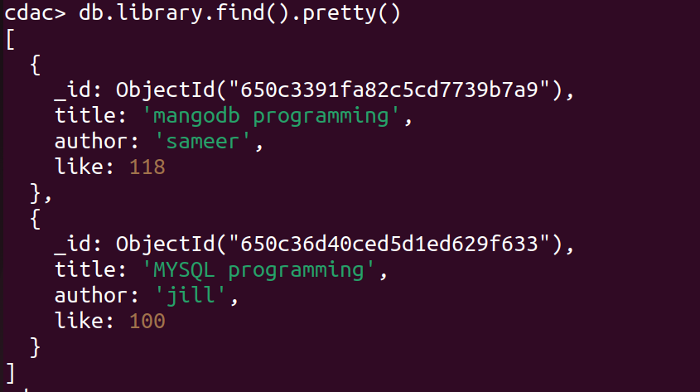

16. Update the document where author name = Sameer and change it to Sameer Dehadrai

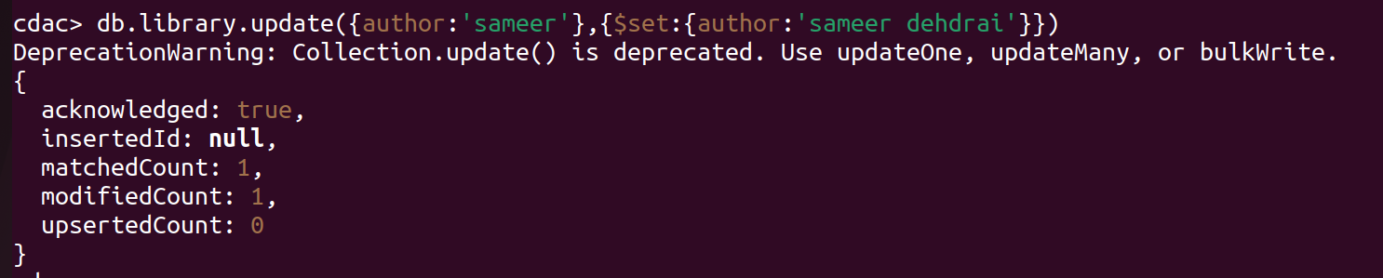
17. Delete all documents that have 100 likes

18. Drop the LIBRARY collection
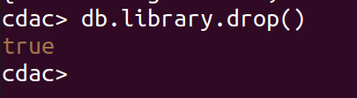

19. Drop the CDAC database
